A)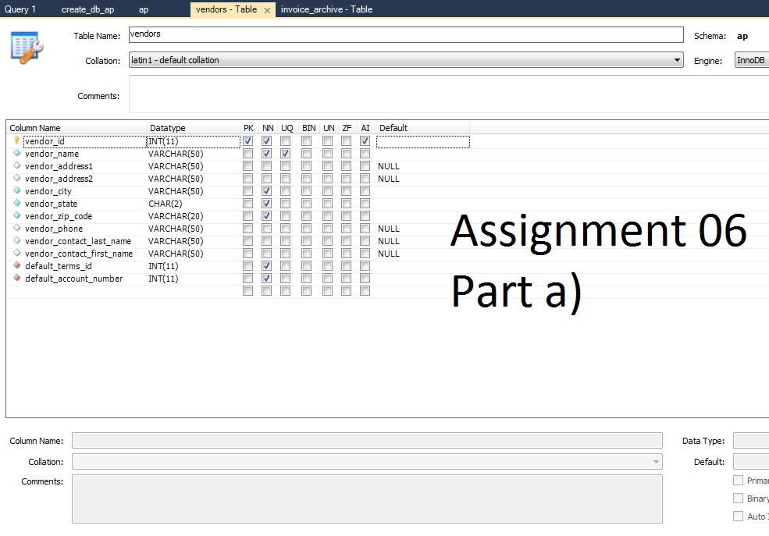

B)

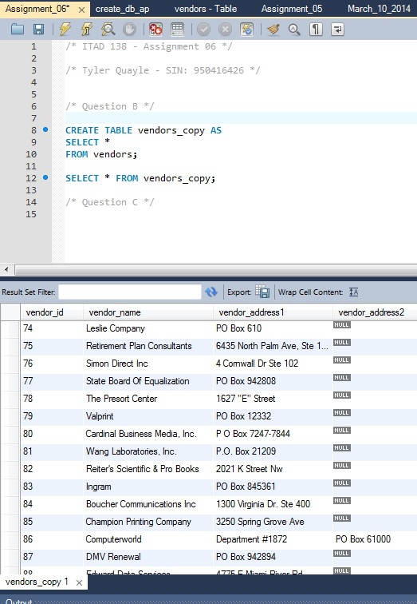

C) The differences between the Vendors and Vendors_copy table is the primary key (vendor_id) is no longer a primary key in Vendors_copy, it reverts back to a normal Int(11) and no longer auto_increments. Meaning you can insert another of the same Vendor_id into the copy and not have any errors thrown

D)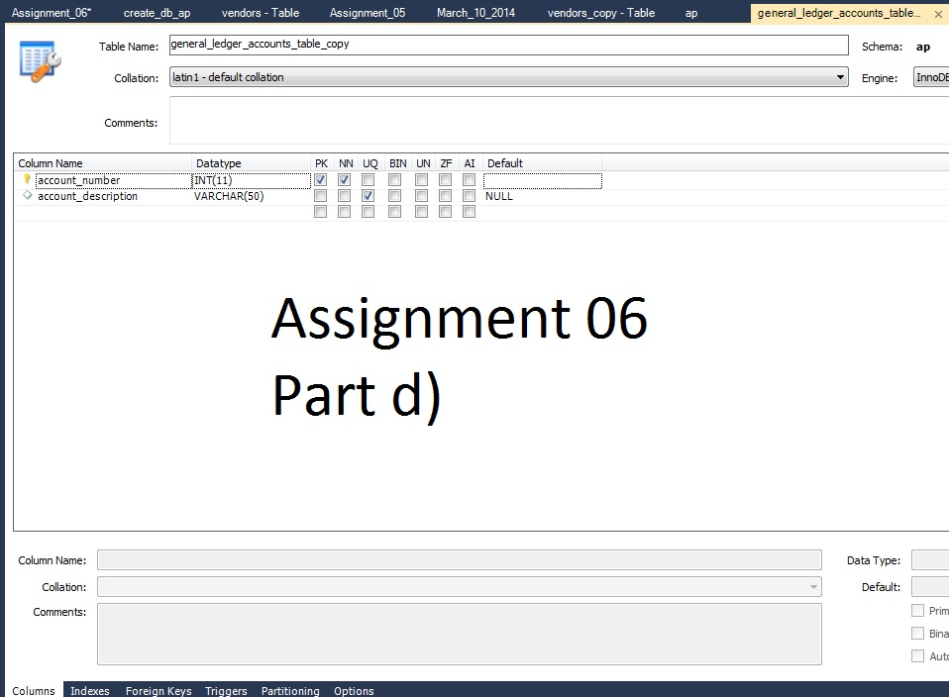

E)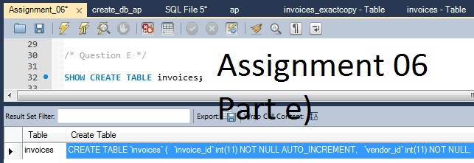

F)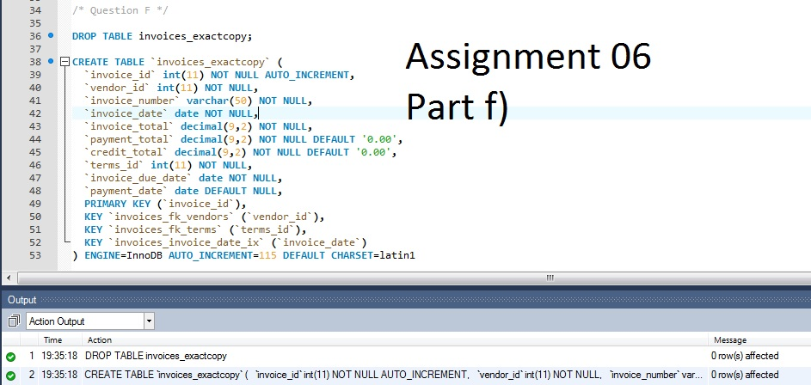

G)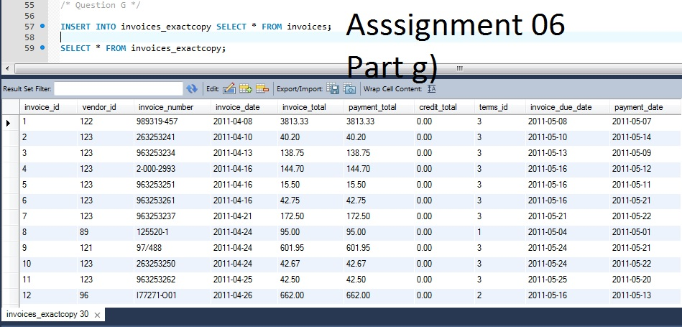

H)